WEEK-14-STRUCTURES AND UNIONS

WEEK-14-STRUCTURES AND UNIONS

REG NO;241801289

NAME :TAMILSELVAN.K

Q1

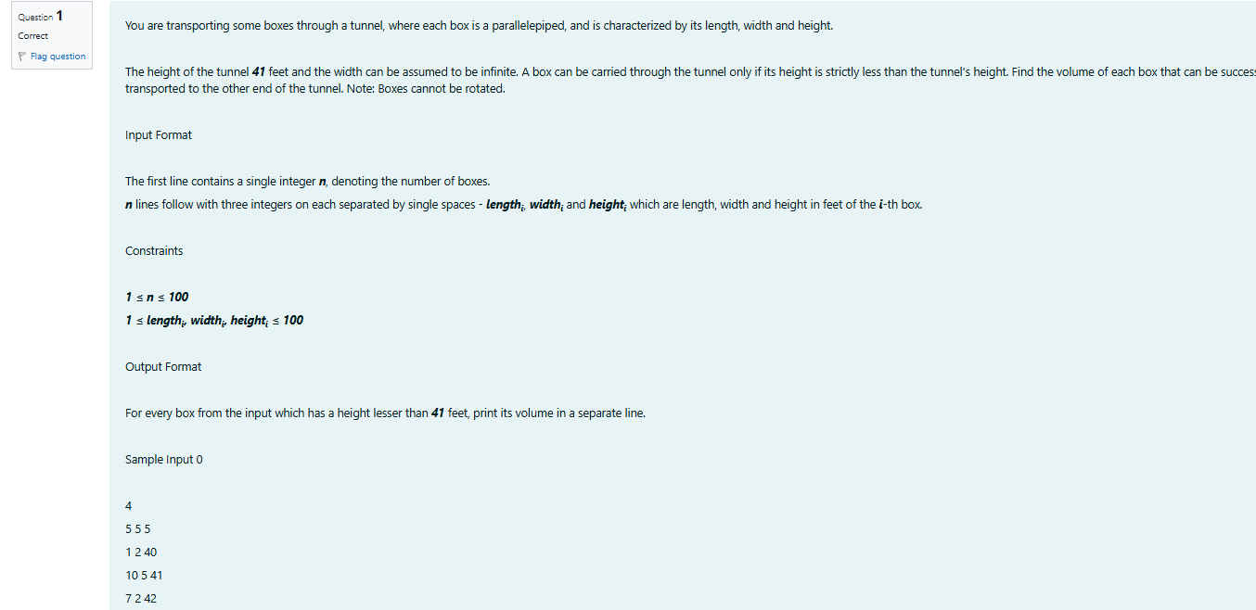

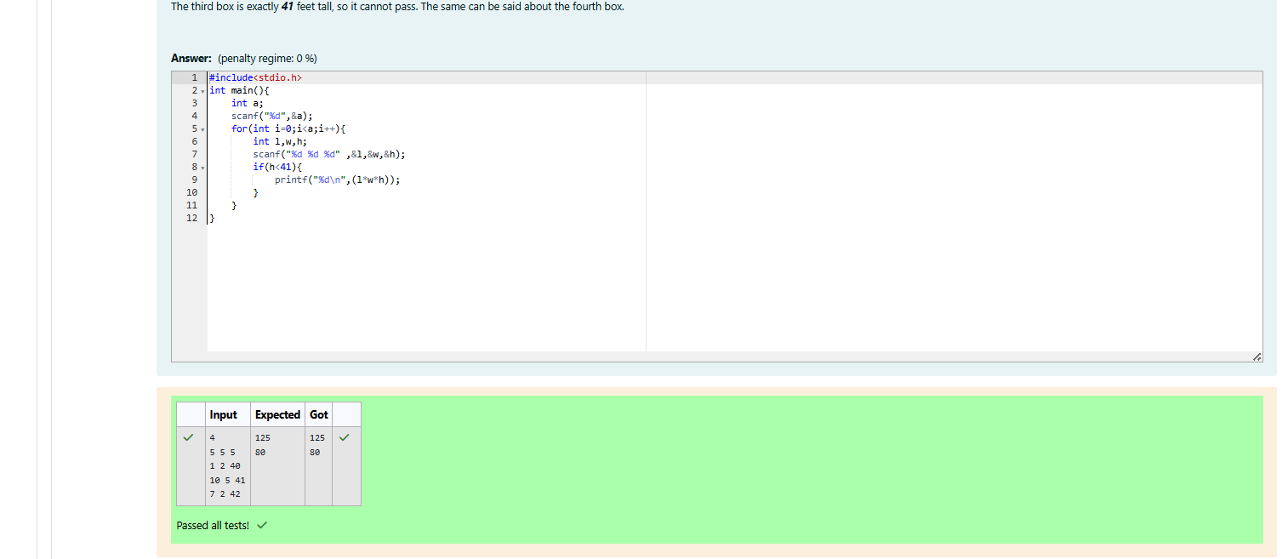

WEEK-14-STRUCTURES AND UNIONS

REG NO;241801289

NAME :TAMILSELVAN.K

Q2

